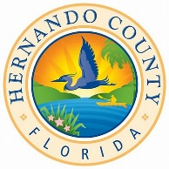2025 Affordable Housing Advisory Committee
MEETING SCHEDULE

January 9, 2025 | Thursday | 10:00 AM
February 13, 2025 | Thursday | 10:00 AM
March 13, 2025 | Thursday | 10:00 AM
April 10, 2025 | Thursday | 10:00 AM
May 8, 2025 | Thursday | 10:00 AM
June 12, 2025 | Thursday | 10:00 AM
July 17, 2025 | Thursday | 10:00 AM
August 14, 2025 | Thursday | 10:00 AM
September 11, 2025 | Thursday | 10:00 AM
October 9, 2205 | Thursday | 10:00 AM
November 13, 2025 | Thursday | 10:00 AM
December 11, 2025 | Thursday | 10:00 AM

Unless noted otherwise: All meetings are held in the Hernando County Government Center, County Commission Chambers (John Law Ayers room) located at 20 N. Main Street, Brooksville, Florida.

